What is Spring MVC?

What is MVC Design Pattern?

What is Web application?

Why Spring MVC?

What is the problem without MVC Design Pattern?

Working with Spring MVC?

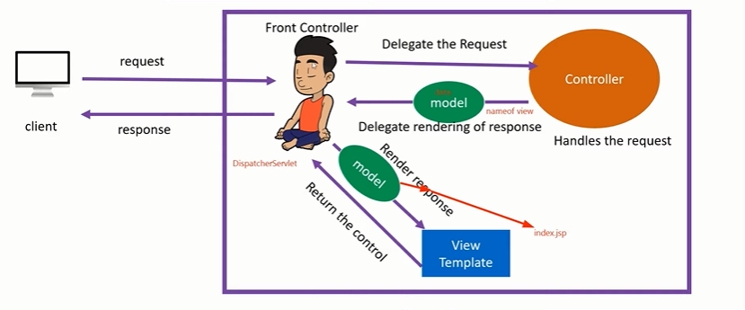

jj

.

How to Create MVC Project?

Create new Maven project -> in filter type org.apache.maven - > select archtype – webapp 1.4

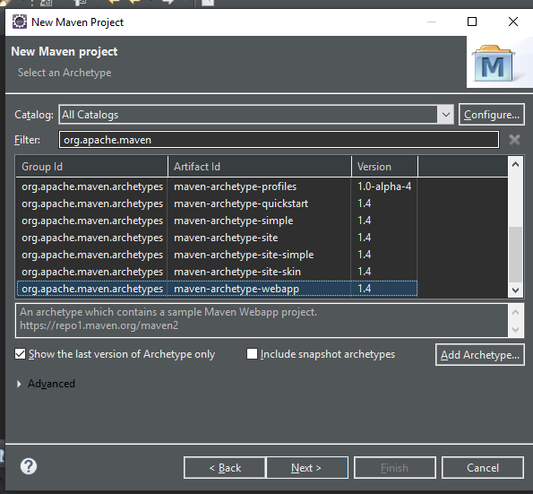

Click next-> group id can be your package name - > artefact ID can be your project name

Click on finish.

1. Go to src/main/webapps/WEB-INF
2. Delete the web.xml file
3. Right Click on Project Name
4. Show in – System Explorer
5. Go inside the project -> go inside .setting -> Right click on xml file - > update version as 3.1 from 2.3.
6. Back to eclipse
7. Right click on project -> JAVA EE TOOLS -> UPDATE EAR LIBRARIES
8. AGAIN Right click on project -> JAVA EE TOOLS -> Generate deployment descriptor
9. Now, You will not be seeing src/main/java folders for the reason
10. Right click on project -> build path -> configure build path -> order and export -> select
    1. src/main.java
    2. Src/test/java

Now click on Apply and close

1. Now go to src down to deployed resources
   1. Src/main/webapp/
      1. You will see index.jsp with error
      2. To remove that error need to add Servlet JAR
2. Servlet JAR Dependecy

<!-- https://mvnrepository.com/artifact/javax.servlet/javax.servlet-api -->

<dependency>

<groupId>javax.servlet</groupId>

<artifactId>javax.servlet-api</artifactId>

<version>3.1.0</version>

<scope>provided</scope>

</dependency>

1. Add one more dependency
   1. Spring Web MVC

Spring Web MVC Dependecy

<!-- https://mvnrepository.com/artifact/org.springframework/spring-webmvc -->

<dependency>

<groupId>org.springframework</groupId>

<artifactId>spring-webmvc</artifactId>

<version>5.2.9.RELEASE</version>

</dependency>

Note:

If we add Spring Web MVC dependency, it will all other dependency which are needed to create spring core project

1. Spring core

5.2.9.Relieas

1. Spring context

5.2.9

1. Web.xml configuration

<servlet>

<servlet-name>dispatcher</servlet-name>

<servlet-class>org.springframework.web.servlet.DispatcherServlet</servlet-class>

</servlet>

<servlet-mapping>

<servlet-name>dispatcher</servlet-name>

<url-pattern>/</url-pattern>

</servlet-mapping>

1. We can given any name in <servlet-name> tag but we need to create the file for front controller with the name passed in <servlet-name> along with -servlet.xml

For example if you have passed <Servlet-name> Spring </Servlet-name>

Then we need to create file with name Spring-servlet.xml other wise it will not work

Hibernate EntityManager Relocation » 5.4.10.Final

<!-- https://mvnrepository.com/artifact/org.hibernate/hibernate-entitymanager -->

<dependency>

<groupId>org.hibernate</groupId>

<artifactId>hibernate-entitymanager</artifactId>

<version>5.4.10.Final</version>

</dependency>

Hibernate Core Relocation » 5.4.10.Final

<!-- https://mvnrepository.com/artifact/org.hibernate/hibernate-core -->

<dependency>

<groupId>org.hibernate</groupId>

<artifactId>hibernate-core</artifactId>

<version>5.4.10.Final</version>

</dependency>

MySql Dependency

<!-- https://mvnrepository.com/artifact/mysql/mysql-connector-java -->

<dependency>

<groupId>mysql</groupId>

<artifactId>mysql-connector-java</artifactId>

<version>5.1.38</version>

</dependency>

Lombok

goto maven repositories

search project lombok

<!-- https://mvnrepository.com/artifact/org.projectlombok/lombok -->

<dependency>

<groupId>org.projectlombok</groupId>

<artifactId>lombok</artifactId>

<version>1.18.12</version>

<scope>provided</scope>

</dependency>

Note : install the JAR file if not installed already

add jar in POM

----------------------------------------------------------------------------

persistence.xml configuration

create src folder inside project with name

***src/main/Resource****

under that

create folder with name (META-INF) - > create persistence.xml

and paste below configuration

----------------------------------------------------------------

<?xml version="1.0" encoding="UTF-8"?>

<persistence version="2.1"

xmlns="http://xmlns.jcp.org/xml/ns/persistence"

xmlns:xsi="http://www.w3.org/2001/XMLSchema-instance"

xsi:schemaLocation="http://xmlns.jcp.org/xml/ns/persistence http://xmlns.jcp.org/xml/ns/persistence/persistence_2_1.xsd">

<persistence-unit name="demo"

transaction-type="RESOURCE_LOCAL">

<provider>org.hibernate.jpa.HibernatePersistenceProvider</provider>

<properties>

<property name="javax.persistence.jdbc.driver" value="com.mysql.jdbc.Driver" />

<property name="javax.persistence.jdbc.url"

value="jdbc:mysql://localhost:3306/db-name?createDatabaseIfNotExist=true" />

<property name="javax.persistence.jdbc.user" value="root" />

<property name="javax.persistence.jdbc.password" value="root" />

<property name="hibernate.hbm2ddl.auto" value="update" />

<property name="hibernate.show_sql" value="true" />

<property name="hibernate.format_sql" value="true" />

<property name="hibernate.dialect"

value="org.hibernate.dialect.MySQL5Dialect" />

</properties>

</persistence-unit>

</persistence>

Dispatcher-servlet.xml configuration

<?xml version="1.0" encoding="UTF-8"?> <!-- NEED TO REMOVE SCHEMA "p". IT IS NOT PRESENT / 404 FOR THIS URL -->

<beans xmlns="http://www.springframework.org/schema/beans"

xmlns:mvc="http://www.springframework.org/schema/mvc"

xmlns:context="http://www.springframework.org/schema/context"

xmlns:xsi="http://www.w3.org/2001/XMLSchema-instance"

xmlns:p="http://www.springframework.org/schema/p"

xsi:schemaLocation="http://www.springframework.org/schema/mvc

http://www.springframework.org/schema/mvc/spring-mvc.xsd

http://www.springframework.org/schema/beans

http://www.springframework.org/schema/beans/spring-beans-3.0.xsd

http://www.springframework.org/schema/context

http://www.springframework.org/schema/context/spring-context-3.0.xsd">

</beans>

Create one base package - > under that create one more package with name .configuration

Base package Com.mvc

Sub package com.mvc.config

Under that create class with any name and annotate that class with annotation @Configuration

If we use annotation @configuration then that will act as XML file

Inside the file create method to return the object for class

InternalResourceViewResolver

package com.mvc.config;

import org.springframework.context.annotation.Bean;

import org.springframework.context.annotation.ComponentScan;

import org.springframework.context.annotation.Configuration;

import org.springframework.web.servlet.view.InternalResourceViewResolver;

@Configuration

public class ConfigurationClass {

@Bean

public InternalResourceViewResolver name() {

InternalResourceViewResolver **resolver** = new InternalResourceViewResolver();

resolver.setPrefix("/WEB-INF/views/");

resolver.setSuffix(".jsp");

return **resolver**;

}

}

As we following the MVC pattern, before returning the page to the user we have view resolver who resolves the page and returns the page. So above bean will be used to perform the same task

It will add the prefix and suffix to the page that being returned

For example

Hello page is being returned

Then above bean will add **/WEB-INF/views/hello.jsp as we have provided the suffix and prefix so it becomes complete path of the file that being returned**

**@Configuration**

* **Class annotated with @Configuration represents annotation based configuration of the xml based configuration when we want IOC to create object for the bean defined in the xml file that we are writing bean in the java class and annotating class with @Configuration so that IOC will look for bean in the respective class and create object for us**
* **Class annotated with @Configuration will act like IOC for us.**

**@Bean**

* **This annotation is used with the method which returns the object for particular class.**
* **When we annotate any method with @Bean then IOC will be able to provide Object for the particular class implicitly.**

**Now, under the base package create another package for controller layer**

**Com.mvc.controller**

package com.mvc.controller;

import org.springframework.stereotype.Controller;

import org.springframework.web.bind.annotation.RequestMapping;

@Controller

public class ControllerClass {

@RequestMapping("/Home")

public String getHomepage() {

return "Homepage";

}

}

@Controller

* It is stereotype annotation.
* If we make use of @Controller annotation then it represents that particular class as controller class. If the class is annotated with @controller then dispatcher scans for such classes for mapped method and detects @RequestMapping, @GetMapping, @PostMapping annotations

@RequestMapping(“/requestedpagename”)

This annotation is used to map the url request with the method with annotated with @RequestMapping which responsible to handle the request for the requested url

Example given below.

**Sending data from controller to view(jsp page)**

**We have two ways**

* 1. **Model <Interface>**
     1. **Model is an interface which is used to send data from controller to a JSP page.**

**Methods present**

**addAttribute(Object object)**

**addAttribute(“key”, “value”)**

**it has many more method above two are widely used methods**

**Create Controller method which will transfer the data to View “login” which is nothing but JSP page**

**@Controller**

**public class ControllerClass {**

**@RequestMapping("/login")**

**public String getLogin(Model model) {**

**model.addAttribute("name", "shubham");**

**return "login";**

**}**

**}**

**Create JSP page login page with name login.jsp as we are returning login in above method. Under views folder create page.**

**Login.jsp**

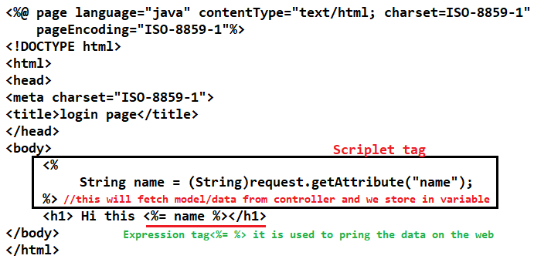

**To get this on the web browser we need pass the url along with requestmapping path**

**@RequestMapping("/login") localhost:8080/projectname/login**

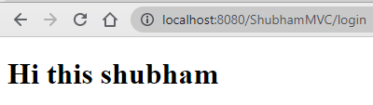

* 1. **ModelMap <Class>**
     1. **ModelMap is a Class which is used to send data from controller to a JSP page.**

**Methods present**

**addAttribute(Object object)**

**addAttribute(“key”, “value”)**

**it has many more method above two are widely used methods**

* + 1. **ModelMap is quite same as Model interface.**
    2. **You can use ModelMap reference to send the data in the above example.**

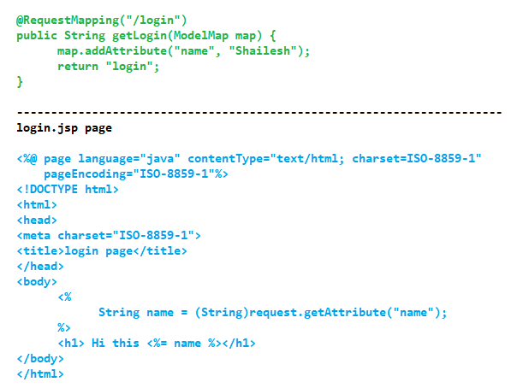

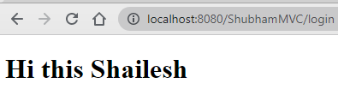

**.**

* 1. **ModelAndView** 
     1. **It has method addObject(String key, Object value)**

@Controller

public class ControllerClass {

@RequestMapping("/login")

public ModelAndView getLogin() {

//Create object for ModelAndView Object

ModelAndView mav = new ModelAndView();

mav.addObject("name", "ShubhamPardesie");

mav.setViewName("login");

return mav;

}

}

Login.jsp

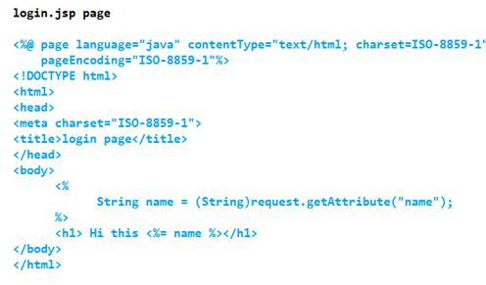

Output

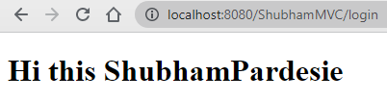

When make use of ModelAndView to transfer data to jsp page we set the data along with the view (jsp page) where data needs to be displayed

When we used Model and ModelMap **we were returnining View name.**

But here are returning object for ModelAndView

1. **JSP Expression Language to print values**

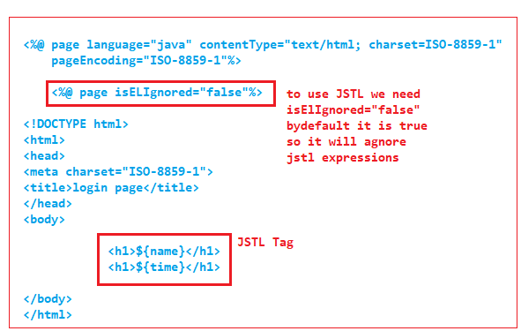

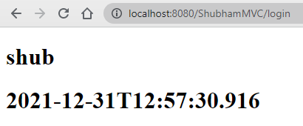

JSTL Dependency.

<!-- https://mvnrepository.com/artifact/javax.servlet/jstl -->

<dependency>

<groupId>javax.servlet</groupId>

<artifactId>jstl</artifactId>

<version>1.2</version>

</dependency>

Add taglib in jsp page to use JSTL

**<%@ taglib prefix="fmt" uri="http://java.sun.com/jsp/jstl/fmt" %>**

* **Sending Data from View to Controller**

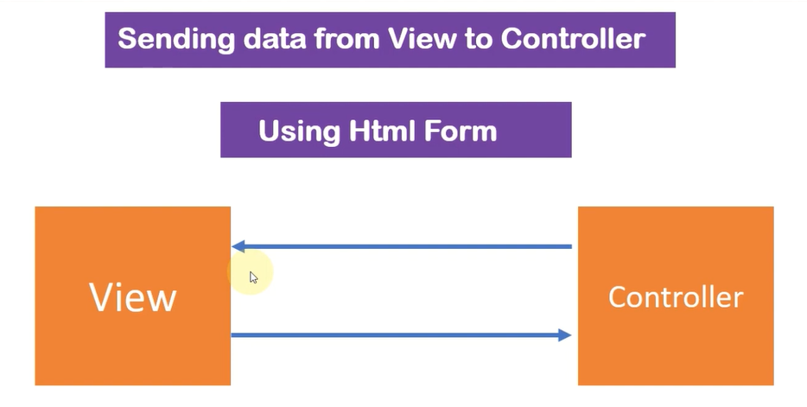

1. Using HTML form using submit button

**How to get data from JSP page to Controller**

1. @RequestParam
2. @ModelAttribute
3. HttpServletRequest request

**@RequestMapping(“/url”)**

**@RequestMapping(path = "/login", method = RequestMethod.POST)**

**public void name(String name) {**

**System.out.println(name);**

**}**

**This Annotation can be used to Class as well as Method**

**It is used to map the request URL such as /home on to and particular handler method**

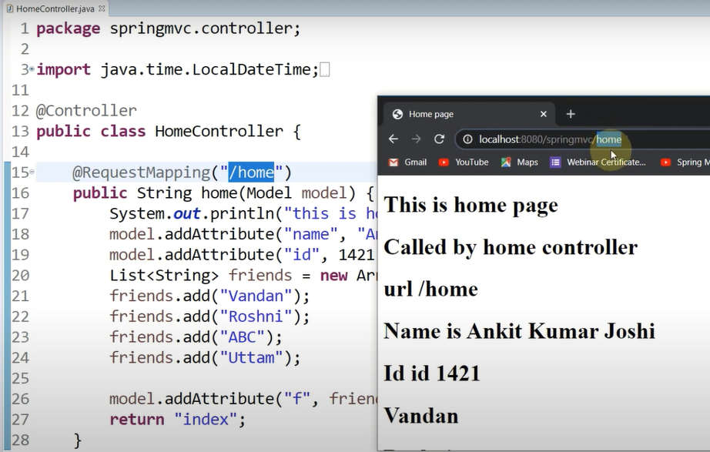

How to use @RequestMapping(“/”) on class?

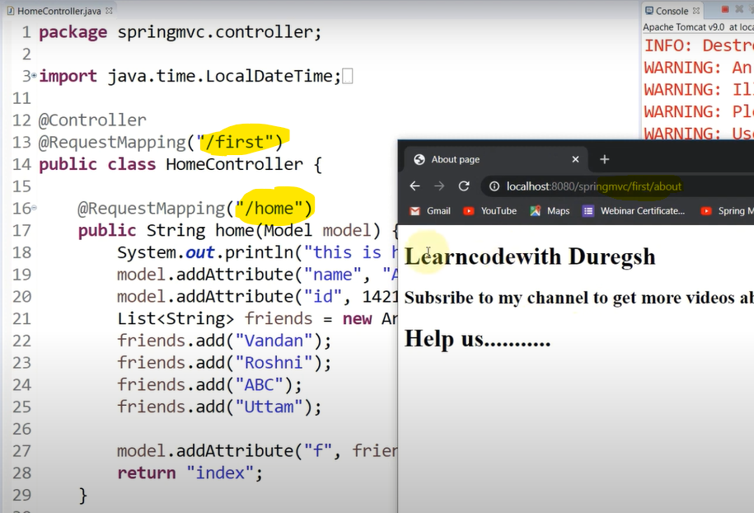

* **Creating HTML form to Take input from user**

1. Using HTML Form

To fetch the data from View to controller we can use

**First Way**

HttpServletRequest request object

This request object will hold the complete HTML form data

That we can get with the help of **request.getAttribute (“fieldname”)**

Public String formData(HttpServletRequest request){

request.getParameter(“fieldname”);

return “viewname”;}

@RequestMapping(path = "/login", method = RequestMethod.POST)

public void name(@RequestParam("name") String name,

@RequestParam("password") String password) {

System.out.println(name + " " +password);

}

}

@RequestParam(“htmlfieldname”) datatype variable

Is used as replacement for HttpServletRequest request object

If we use above annotation we need not write extra lines of code to fetch the data from view

request.getParameter(“field’)

@RequestParam(“htmlfieldname”) datatype variable

This annotation will get us the data from view and will starte in the

datatype variable.

Data stored in the variable we make use of it anytime.

**Second Way**

Working with @RequestParam

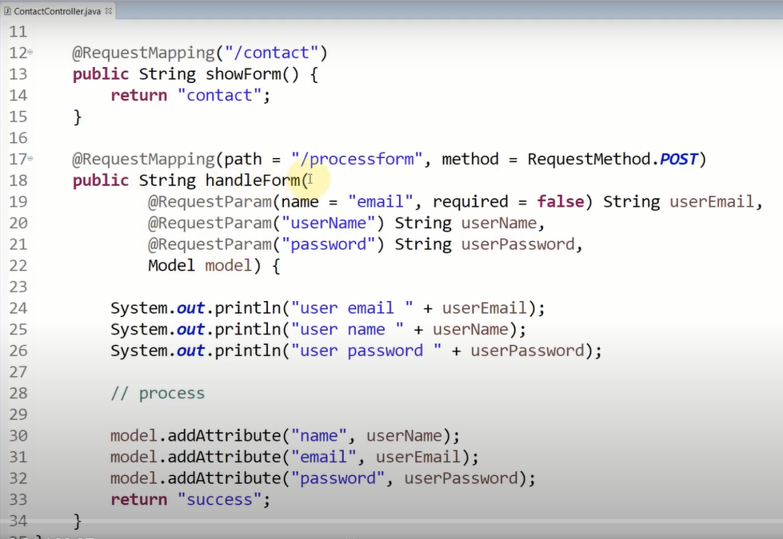

**Third Way**

**Fourth Way**

(@ModelAttribute **Classname** **objectreference**)

Create class Student class

package com.mvc.bean;

import lombok.Data;

@Data

public class Student {

private String name;

private String password;

}

JSP Page :

<form action="login" method="post">

<input type="text" name="name">

<input type="text" name="password">

<input type="submit" value="Submit">

</form>

Data members in Student class and Fieldname in View should be matching else ModelAttribute will not work

**Fourth Way** (@ModelAttribute Student student

@RequestMapping(path = "/login", method = RequestMethod.POST)

public String name(@ModelAttribute Student student) {

**System.out.println(student.getName() + " " + student.getPassword());**

**return “login”;**

}

Spring ORM

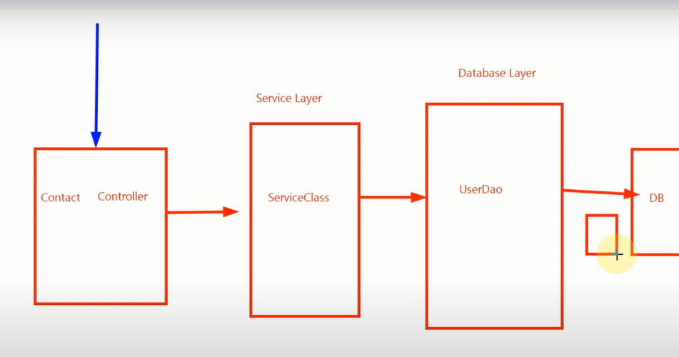

We use interfaces to achieve loose coupling

@configuration

@Controller

@Service

@Repository

@ID

@Entity

@Column

@Value

@GeneratedValue(Strategy=GenerationType.Auto)

@Autowired

@Transactional

How to redirect in Spring MVC

1. HttpServletResponse

We can use HttpServletResponse response

Response.sendRedirect(“path”)

But it is not recommended to use it because there would no meaning of using Spring MVC if we are using old Servlet way

1. Redirect prefix

@Controller

public class ControllerClass {

@RequestMapping("/login")

public String getLogin() {

return "redirect:/homepage";

}

@RequestMapping(path = "/homepage")

public String name() {

return "Homepage";

}

}

1. RedirectView

@Controller

public class ControllerClass {

@RequestMapping("/login")

**public RedirectView getLogin () {**

RedirectView view =new RedirectView ();

view.setUrl("**homepage**");

return view;

}

@RequestMapping (path = "/**homepage**")

public String name () {

return "**Homepage**";

}

}

**@SessionAttrinute(name=”” required=false) non-premitiveDatatype variablename)**

@PostMapping("/welcome")

public String getWelcome(@ModelAttribute AdminLogin login,ModelMap map, HttpServletRequest request) {

HttpSession session = request.getSession();

if(service.validate(login)) {

map.addAttribute("msg", "logged in Successfully");

map.addAttribute("login", login);

session.setAttribute("loggedin", login);

return "welcome";

}else {

map.addAttribute("errmsg", "Something went wrong");

return "Home";

}

}

@PostMapping("/delete")

public String deleteEmp(ModelMap map, @ModelAttribute EmpDB db, @SessionAttribute(name = "loggedin", required = true) AdminLogin **login**) {

if(**login**!=null) {

if(service.deleteEmp(db)) {

map.addAttribute("msg", "record has been deleted successfully");

}else {

map.addAttribute("msg", "Could not find employee");

}

return "delete";

}else {

map.addAttribute("msg", "Please Login First");

return "Home";

}

}

@GetMapping("/logout")

public String getLogout(ModelMap map, HttpSession session) {

session.invalidate();

map.addAttribute("msg", "Logged out successfully");

return "Home";

}